Here is a step by step guide on how to book:
Group Code: WCW0525 (All Caps-No Spaces)
Travel Window: Between May 11&18, 2025
Booking Window: from now until April 25, 2025
How to Book:
- Option 1: you can use our Call Center by dialing 1-866-237-3267, make sure you inform the agent of the group code or you will be charged the regular rate, only by providing the group code will the agent be able to confirm your reservation with the discounted rates.
- Option 2: you can enter our website https://bookings.hyattinclusivecollection.com/?country=US and select Dominican Republic as the Country, select Punta Cana as City, select Dreams Royal Beach for hotel, select the amount of guests who will occupy the room and select your travel dates between May 11&18, 2025 and enter your discount code and click on “book now”, it should look like this
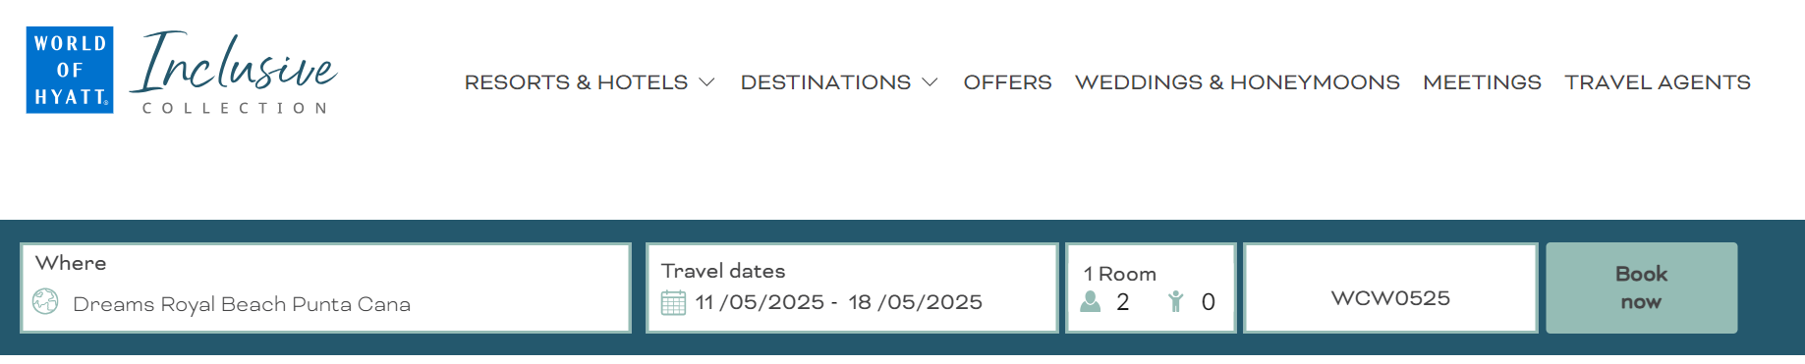

- Once you click “book now” you will be redirected to the reservation site and you will see the rooms with the discounted rates, here you just need to select the room type you want to reserve by clicking on it and follow the reservation steps, once your 1-night deposit is charged you will receive an email with your room confirmation as well as a link to modify your reservation if needed.
